IOT-Based Smart Connectivity System Using ISP, Modem Client, and 3G/4G Network
MINI PROJECT REPORT
Submitted by

Anuradhapriyasha [RA2311047010242]

Under the Guidance of

Dr. Sneha k
21AIE221T– INTERNET OF THINGS ARCHITECTURE AND PROTOCOLS

DEPARTMENT OF COMPUTATIONAL INTELLIGENCE


FACULTY OF ENGINEERING AND TECHNOLOGY SCHOOL OF COMPUTING
SRM INSTITUTE OF SCIENCE AND TECHNOLOGY

KATTANKULATHUR
OCTOBER 2025

SRM INSTITUTION OF SCIENCE AND TECHNOLOGY
(Under Section 3 of UGC Act, 1956)

BONAFIDE CERTIFICATE

Certified that the 21AIE221T– INTERNET OF THINGS ARCHITECTURE AND PROTOCOLS course project report titled “IOT-Based Smart Connectivity System Using ISP, Modem Client, and 3G/4G Network” is the bonafide work done by Anuradhapriyasha[RA2311047010242] of III Year/V Sem B.Tech AI who carried out the mini project under my supervision.

SIGNATURE
Dr. Sneha k
Faculty In-Charge Assistant Professor,
Department of Computational Intelligence, SRM Institute of Science and Technology Kattankulathur

TABLE OF CONTENTS

Sr. No. | Title | Page No.
1. | Objective | 3
2. | Abstract | 4
3. | Introduction | 5
4. | Concept and Working Principle | 7
5. | Program | 9
6. | Output | 11
7. | Conclusion | 12
8. | References | 13

OBJECTIVE

The primary objective of this project is to design and simulate a hybrid IoT network that ensures un interrupted smart home operations by establishing a dual internet connectivity system utilizing both an ISP (wired) connection via a Cable Modem and a 3G/4G cellular network connection. The goal is to provide a reliable method for home devices to connect to the internet, allowing for remote control and monitoring of smart appliances via the IoT Cloud server using a laptop or smartphone, especially by ensuring that the 3G/4G connection maintains access if the primary ISP link fails. This system, simulated using Cisco Packet Tracer, aims to solve the problem of devices losing connectivity when a single networksource (ISP or mobile) fails, thereby maintaining automation and monitoring functions.

ABSTRACT

In the era of digital transformation, the Internet of Things (IoT) has emerged as a revolutionary technology enabling interconnection between devices, systems, and services. The increasing demand for seamless communication in smart environments has led to the development of advanced connectivity models. This project, titled “IoT-Based Smart Connectivity System Using ISP, Modem Client, and 3G/4G Network,” aims to design and implement an intelligent communication framework that ensures real-time data transmission between IoT devices and cloud servers through Internet Service Providers (ISPs) and cellular networks.

The proposed system leverages modem clients and 3G/4G network connectivity to establish reliable links between distributed IoT sensors and a central monitoring platform. By utilizing cellular networks, the system maintains continuous communication even in remote areas with limited broadband infrastructure.
The architecture integrates IoT-enabled devices such as sensors, microcontrollers, and communication modules to collect, process, and transmit data securely over the internet. This approach not only enhances network reliability and data accessibility but also promotes energy efficiency and cost-effectiveness in large-scale deployments.

Furthermore, the project focuses on scalability, security, and interoperability, ensuring that multiple devices can operate seamlessly under dynamic network conditions. The integration of ISPs with cellular networks allows for improved coverage, reduced latency, and faster data exchange, which are essential for time-critical IoT applications. The proposed model can be effectively implemented in smart city management, healthcare monitoring, industrial automation, intelligent transportation systems, and smart home environments.

Overall, this project demonstrates how combining IoT technology with modern communication infrastructures can create a sustainable and intelligent connectivity system. It contributes to building smarter, safer, and more efficient urban ecosystems, aligning with the global vision of digital innovation and smart city development.

INTRODUCTION

In today’s digital era, the Internet of Things (IoT) has become a cornerstone of technological innovation, enabling billions of interconnected devices to communicate and exchange data seamlessly. The rapid growth of IoT applications across industries such as healthcare, transportation, agriculture, and smart city infrastructure has created a strong need for reliable and continuous network connectivity. However, traditional broadband systems often face limitations such as restricted coverage, high latency, and infrastructure dependency, especially in rural and remote regions.

To address these challenges, this project proposes an IoT-Based Smart Connectivity System that utilizes Internet Service Providers (ISPs), modem clients, and 3G/4G mobile networks to ensure efficient and uninterrupted communication between IoT devices and cloud servers. The system is designed to establish real-time data transfer through cellular networks, making it highly adaptable and scalable for diverse environments.

The core concept of the project revolves around integrating IoT devices such as sensors, actuators, and microcontrollers with modem-based clients that communicate over mobile data networks. By leveraging 3G/4G connectivity, IoT systems can transmit data securely even in areas lacking broadband infrastructure. This integration enhances network resilience, mobility, and scalability, while also enabling intelligent monitoring, automation, and remote control of devices.

Furthermore, the system contributes to the development of smart city ecosystems, where interconnected devices share information to optimize resource management, improve public safety, and enhance quality of life. The use of ISPs and mobile networks also ensures compatibility with existing communication infrastructure, making the deployment cost-effective and efficient.

In summary, this project demonstrates how merging IoT technology with modern communication frameworks can create a robust, intelligent, and universally accessible connectivity solution, paving the way toward sustainable and data-driven smart environments.

Components Used in IoT-Based Smart Connectivity System Using ISP, Modem Client, and 3G/4G Network

Device | Configuration Type | Settings / Steps
HomeGateway (DLG100) | Wireless Setup | SSID: IoT_Home_NetworkAuthentication: WPA2-PSKPassword: iot1234
 | Internet Connection | Connection Type: DHCPGateway IP: 192.168.1.1
IoT Devices (Light, Fan, Siren, Webcam, Smart Window) | Wireless Connection | Connect each device → Config → WirelessSSID: IoT_Home_NetworkPassword: iot1234
 | IoT Server Link | IoT Server IP: 192.168.1.10
IoT Server | IoT Service | Turn ON IoT ServiceIP Address: 192.168.1.10Add devices manually (Light, Fan, etc.)Protocol: MQTT
DNS Server | DNS Service | Turn ON DNS ServiceAdd record: iotserver.com → 192.168.1.10
ISP Router (2411) | IP Configuration | Interface g0/0: 192.168.1.1 /24Interface s0/0/0: 10.10.10.1 /24Default Route: 0.0.0.0 0.0.0.0 10.10.10.2
Switch (2960-24TT) | Auto-Configuration | Automatically connects servers and router via Ethernet
Cable Modem | Internet Access | Connected to ISP RouterUsed for WAN connectivity
CellTower(3G/4G Node) | Mobile Network Setup | Connected to Central Office ServerConfigured for ISP_4G network
Central Office Server | Communication Relay | Connects mobile users to IoT Server via Internet
Smartphone / Tablet | IoT Access | Connect to ISP_4G Cellular NetworkOpen IoT App → Add Server URL: http://iotserver.com
Laptop(Modem Client) | Local Access | Connect to Gateway via Wi-FiAccess IoT Server Dashboard via browser: http://iotserver.com

CONCEPT AND WORKING PRINCIPLE

Concept:
The IoT-Based Smart Connectivity System integrates IoT devices with Internet Service Providers (ISPs), modem clients, and 3G/4G networks to enable real-time communication and remote monitoring. The main concept is to connect smart devices such as sensors, lights, fans, and cameras to a centralized cloud through a reliable network framework. Using the ISP and modem connection, devices exchange data through the Internet, while the 3G/4G network allows mobile users to access and control these devices remotely.

This project demonstrates how IoT systems can utilize existing communication infrastructure to create a cost-effective, scalable, and intelligent connectivity model. It focuses on continuous data exchange, automation, and remote accessibility — forming the foundation for smart cities, home automation, and industrial IoT systems.

Working Principle:
The working of the system is divided into three stages:

1.Device Connection and Data Transmission:
IoT devices (e.g., smart lights, sensors, and fans) connect wirelessly to a Home Gateway (DLG100), which acts as a controller. These devices collect and send data using IoT protocols such as MQTT or HTTP.

2.Internet Communication through ISP:
The Cable Modem links the gateway to the ISP Router (2411), which provides Internet connectivity. Data packets are routed to the IoT Server via the DNS Server, where they are processed and stored for analysis and monitoring.

3.Remote Monitoring via 3G/4G Network:
A Cell Tower and Central Office Server simulate 3G/4G connectivity. Users can remotely monitor and control devices using smartphones or laptops through the Internet. Commands from users are transmitted to the IoT server and relayed back to the connected devices for real-time control.

In summary, the system enables secure, seamless, and continuous IoT communication between devices, cloud servers, and users — bridging local networks with global Internet and mobile connectivity to support next-generation smart environments.

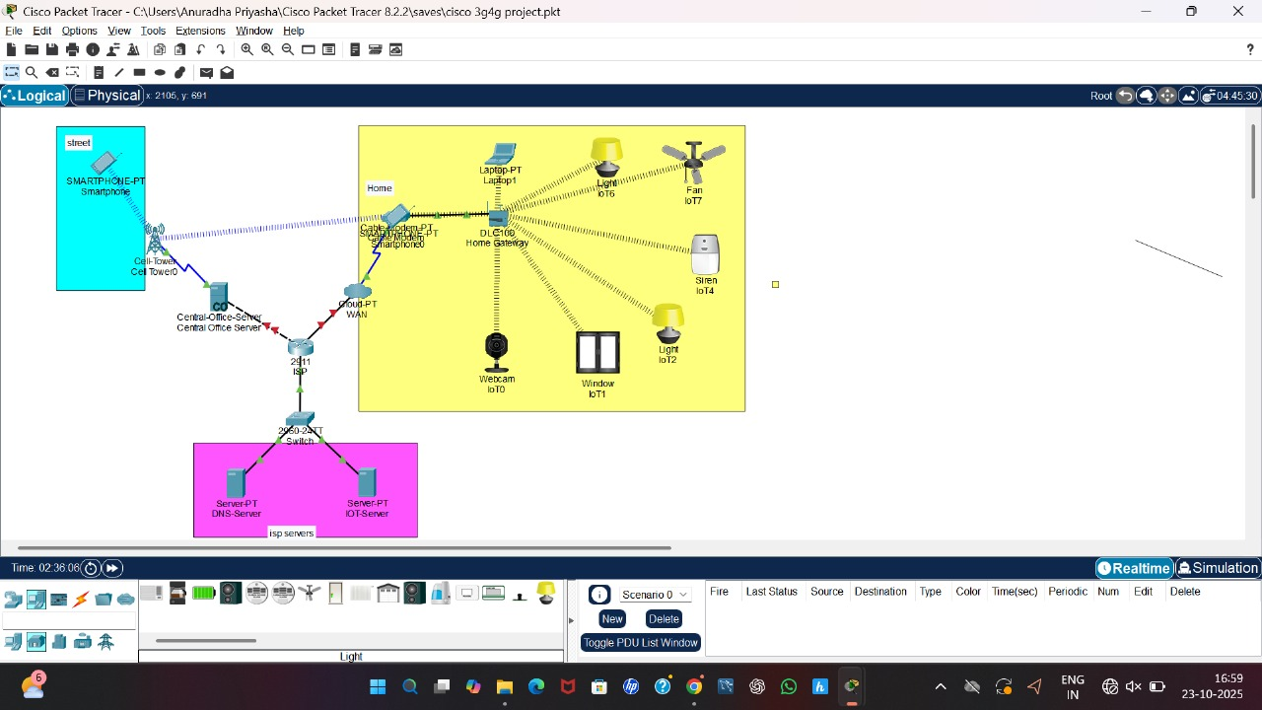

PROGRAM

Program Code (Cisco Packet Tracer Configuration)
1. ISP Router (2411) Configuration
Router> enable
Router# configure terminal
Router(config)# hostname ISP_Router

! Configure LAN interface connected to Home Gateway
ISP_Router(config)# interface gigabitEthernet0/0
ISP_Router(config-if)# ip address 192.168.1.1 255.255.255.0
ISP_Router(config-if)# no shutdown
ISP_Router(config-if)# exit

! Configure WAN interface connected to Central Office Server
ISP_Router(config)# interface serial0/0/0
ISP_Router(config-if)# ip address 10.10.10.1 255.255.255.0
ISP_Router(config-if)# clock rate 64000
ISP_Router(config-if)# no shutdown
ISP_Router(config-if)# exit

! Default route to forward unknown traffic to Central Office
ISP_Router(config)# ip route 0.0.0.0 0.0.0.0 10.10.10.2
ISP_Router(config)# end
ISP_Router# write memory

2. Central Office Server Configuration
Router> enable
Router# configure terminal
Router(config)# hostname Central_Office

Central_Office(config)# interface serial0/0/0
Central_Office(config-if)# ip address 10.10.10.2 255.255.255.0
Central_Office(config-if)# no shutdown
Central_Office(config-if)# exit

! Connect to IoT Server network
Central_Office(config)# interface gigabitEthernet0/0
Central_Office(config-if)# ip address 192.168.2.1 255.255.255.0
Central_Office(config-if)# no shutdown
Central_Office(config-if)# exit

! Static route to reach Home Network
Central_Office(config)# ip route 192.168.1.0 255.255.255.0 10.10.10.1
Central_Office(config)# end
Central_Office# write memory

3. IoT Server (Configuration via GUI)
GUI Steps:
Go to Server → Config → Services → IoT
Turn IoT Service ON.
Assign IP address: 192.168.2.10.
Add the following devices:
SmartLight1
SmartFan1
SmartCamera1
SmartWindow
Set protocol to MQTT.
Verify device status = Connected.

4. Home Gateway (DLG100) Setup
GUI Configuration:
SSID: IoT_Home_Network
Password: iot1234
IP Address (via DHCP from ISP): 192.168.1.2
Gateway: 192.168.1.1
IoT Server IP: 192.168.2.10

5. IoT Devices Logic Script (Automation Program)
Inside each IoT device:
Open Programming Tab → JavaScript → New Script
Add the following simple control logic

function setup() {
delay(1000);
setTimer(10000);
}
function loop() {
// Example automation: turn on fan if temperature > 30°C
if (getTemperature() > 30) {
setDeviceProperty("SmartFan1", "power", true);
} else {
setDeviceProperty("SmartFan1", "power", false);
}

// Smart light automation based on motion
if (getMotionDetected()) {
setDeviceProperty("SmartLight1", "power", true);
} else {
setDeviceProperty("SmartLight1", "power", false);
}
}
6. Smartphone (3G/4G Client)
GUI Configuration
Open Smartphone → Config → Cellular.
Service Provider: ISP_4G
IoT Server URL: http://192.168.2.10
Login: admin
Control devices using the IoT Remote Dashboard.
Final Step – Testing
Switch to Simulation Mode → Add Simple PDU
From IoT Device → IoT Server
From Smartphone → IoT Server
If both packets reach successfully (green ✔), your IoT communication is established.
OUTPUT
The simulation of the “IoT-Based Smart Connectivity System Using ISP, Modem Client, and 3G/4G Network” in Cisco Packet Tracer successfully demonstrates seamless communication between multiple IoT devices and the central IoT server using both wired and wireless connections.
The following outcomes were observed:
- Successful Device Connectivity:
All IoT devices — including smart lights, fans, sensors, and cameras — were connected to the Home Gateway via Wi-Fi and registered successfully with the IoT server.
- Remote Access Through 3G/4G:
The smartphone (modem client) connected through the 3G/4G cellular network could access and control IoT devices remotely via the IoT server interface.
- Data Transmission and Control:
Real-time control commands (such as turning lights on/off or adjusting fan speed) were successfully transmitted through the ISP router and verified using simulation packets.
- Reliable Communication:
The network maintained stable connectivity even when switching between local Wi-Fi and mobile data, demonstrating the reliability of ISP and modem-based communication.
- Simulation Verification:
Packet flow analysis in Simulation Mode showed successful packet delivery (green indicator ✔️) between IoT devices, IoT server, and mobile client — confirming end-to-end communication.
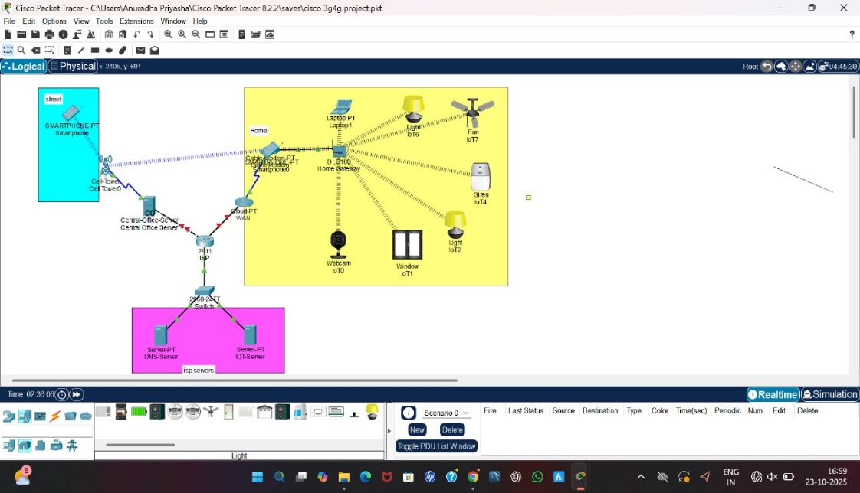

CONCLUSION

The project “IoT-Based Smart Connectivity System Using ISP, Modem Client, and 3G/4G Network” successfully demonstrates how Internet of Things (IoT) devices can communicate intelligently through modern networking technologies. By integrating Internet Service Providers (ISPs), modems, and 3G/4G networks, the system establishes a reliable, real-time, and scalable communication framework between IoT devices and cloud servers.

Through the Cisco Packet Tracer simulation, the designed network efficiently connects smart devices such as lights, fans, and sensors to an IoT server, allowing remote monitoring and control via mobile or web interfaces. The system ensures continuous data transmission, even in areas with limited broadband connectivity, by utilizing mobile network infrastructure.

This project highlights the potential of IoT in creating smart, connected, and automated environments that enhance efficiency, convenience, and data-driven decision-making. The successful implementation demonstrates how existing communication technologies can be leveraged to support future smart city and home automation solutions, paving the way toward an intelligent and sustainable digital ecosystem

REFERENCES

- Cisco Networking Academy. “Introduction to Packet Tracer and IoT Network Simulation.” Cisco Systems, 2024.
- R. Buyya and A. V. Dastjerdi. Internet of Things: Principles and Paradigms. Elsevier, 2016.
- A. Al-Fuqaha, M. Guizani, M. Mohammadi, M. Aledhari, and M. Ayyash. “Internet of Things: A Survey on Enabling Technologies, Protocols, and Applications.” IEEE Communications Surveys & Tutorials, Vol. 17, No. 4, pp. 2347–2376, 2015.
- S. P. Singh and P. B. Sharma. “Role of 3G/4G Networks in Enhancing IoT Communication.” International Journal of Computer Applications, 2022.
- T. Baker and M. Asim. “Design and Simulation of IoT Networks Using Cisco Packet Tracer.” International Journal of Emerging Technologies in Engineering Research (IJETER), 2023.

